Ramadan Prompting

Nights
Scenario-based prompting competition. 30 nights. 30 real-world coding scenarios.
by Sir Asharib Ali · for GIAIC Students
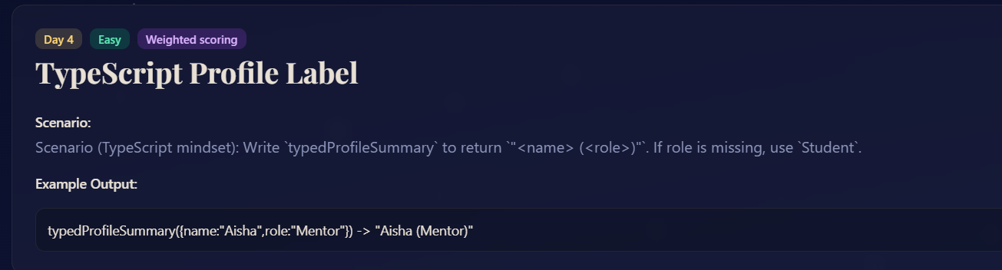

PROMPT:
Goal:
Return a profile summary string in the format "<name> (<role>)" using TypeScript, defaulting role to "Student" if missing.
Constraints:
- Input is an object with name (string) and optional role (string).
- Use default "Student" if role is undefined or empty.
Edge Cases:
- {name: "Rafique"} → "Rafique (Student)"
- {name: "Kanwal", role: ""} → "Kanwal (Student)"
Output Format:
A string: "<name> (<role>)"
Code:
function typedProfileSummary({name, role}) {
return `${name} (${role || "Student"})`;
}

// Examples
console.log(typedProfileSummary({name:"Kiran", role:"Mentor"})); // "Kiran (Mentor)"
console.log(typedProfileSummary({name:"Kanwal"})); // "Kanwal (Student)"

